
Company
Logotype

Cone Beam Computed Tomography- Report



Porur Dental X-rays & CBCT

Patient Name : Mrs. Padmavathi | Date of Report : 30.03.2024
Age/ Gender : 51 years/ Female | Region of Interest : CBCT Full Skull
Referring doctor: Dr. Vikram Vishwanath | Indication : Implant assessment
Clinical Notes: Nil
PATIENT INFORMATION

CBCT- Full Skull provided
CBCT – IMAGE DETAILS

RADIOGRAPHIC INTERPRETATION

- Partial loss of crown structure in relation to: 23
- Presence of hyperdense screw like structure in relation to 13, 25, 38 regions.
- Hyperdense crown structures in relation to 11, 12, 13, 14, 21, 22, 25, 31, 32, 33, 36, 37, 41, 42, 43.
- The periapical region of 31, 32 and 33 is present with diffuse hypodensity.
- The alveolar ridge in relation to the maxillary and mandibular alveolar ridge is present with normal trabecular pattern.

IMPLANT ASSESSMENT

 | 23 region
Sub-Crestal (in mm) | 6.6
Mid- Crestal (in mm) | 6.8
Distance between the alveolar ridge and floor of the maxillary sinus (in mm) | 12.5

RADIOGRAPHIC IMPRESSION

- Fractured crown: 23.
- Implants in relation to 13, 25, 38 regions
- Periapical pathology in relation to 31, 32, 33.

Kindly correlate with clinical findings


IMAGES FOR REFERENCE

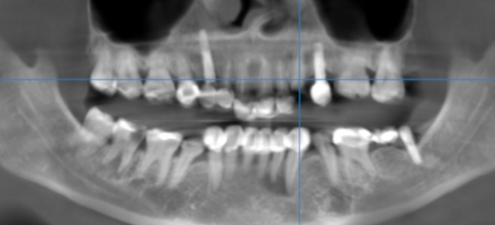

3-DIMENSIONAL VIEW

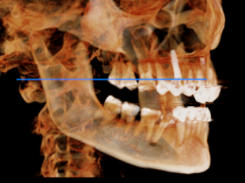
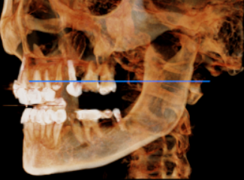

CROSS SECTIONAL VIEW

23 region | 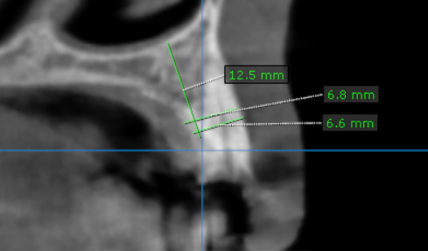

**** End of report ****

